./

GENESIS - Learning Report

Embedded c



|  |  |  |  |  |  |
| --- | --- | --- | --- | --- | --- |
| **Ver. Rel. No.** | **Release Date** | **Prepared. By** | **Reviewed By** | **To be Approved** | **Remarks/Revision Details** |
| 1 | 02/01/2021 | Sowmya Damera |  |  |  |
|  |  |  |  |  |  |
|  |  |  |  |  |  |
|  |  |  |  |  |  |
|  |  |  |  |  |  |

**Details**

**CONTENTS**

**Activity 1: Build Process 4**

**Activity 2: Linker Script 6**

**Activity 3: Startup Code 7**

**Activity 4: Makefile 8**

**Activity-1:**

Build System which is able to create the final executable and compiling it in make file using command prompt of window.

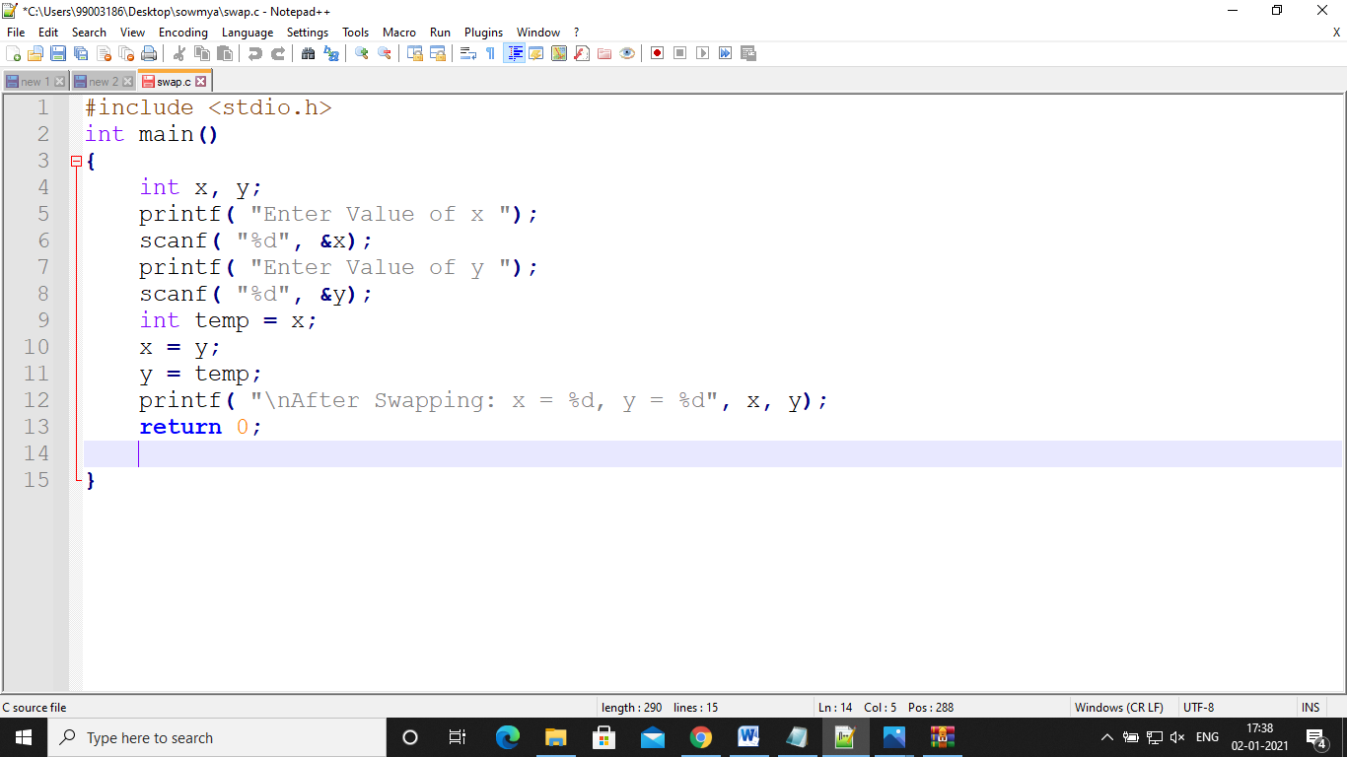

**Make file for build process:**

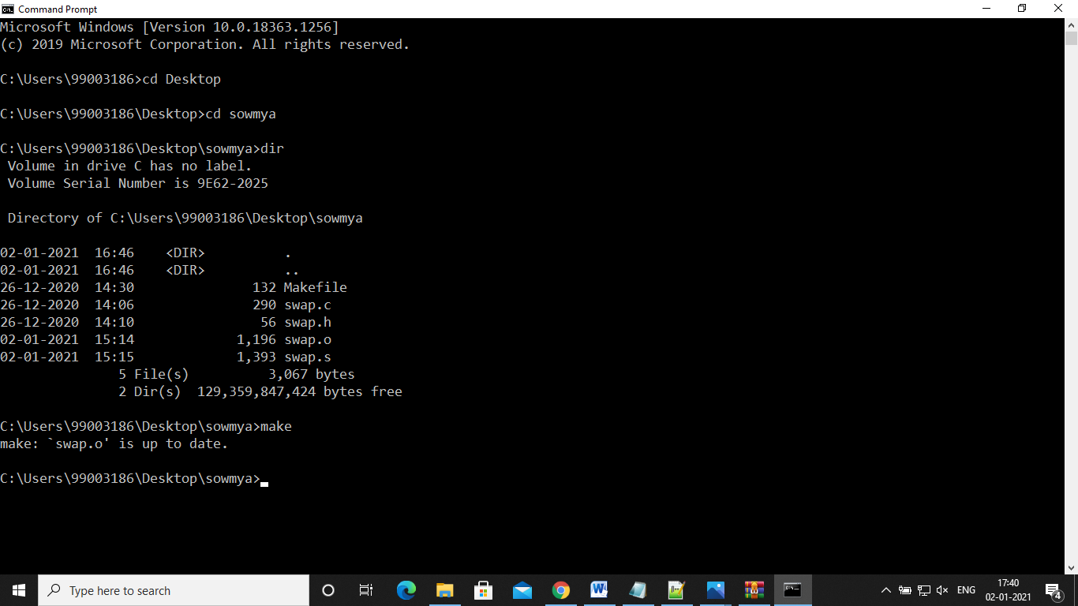

**Activity-2:**

**Linker Script:**

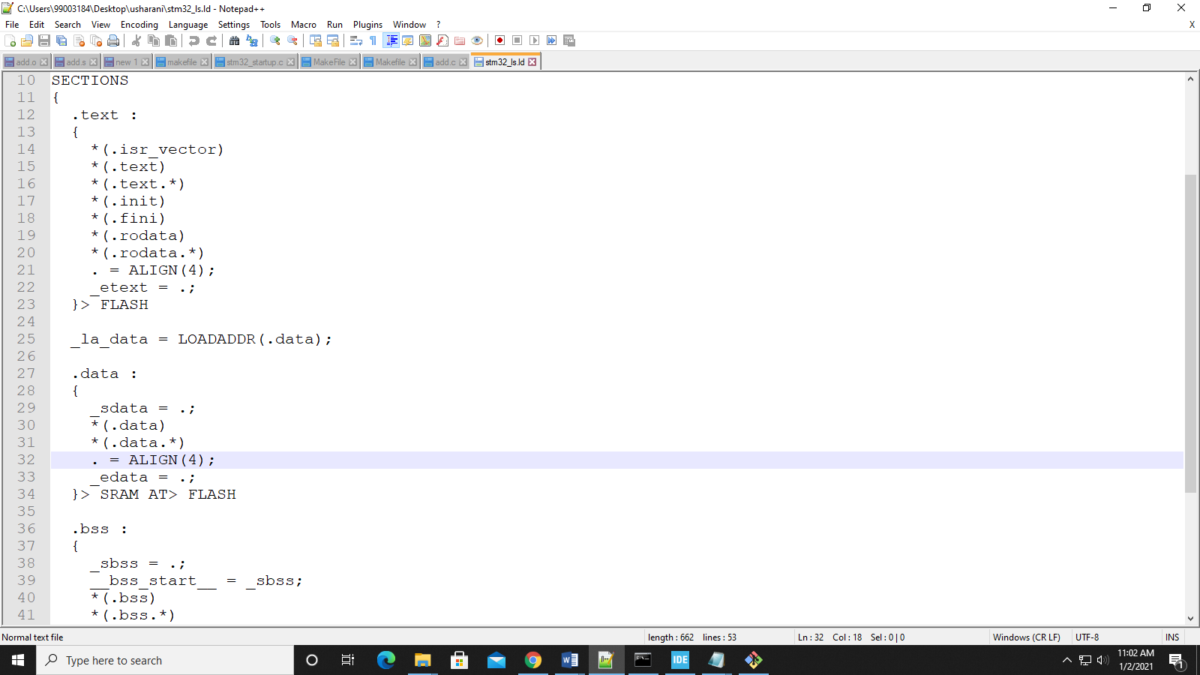

**Activity-3**:

**Start-up Code:**

Various Address of Interrupt Subroutine Vectors(ISR) and its priorities of ISR’s:

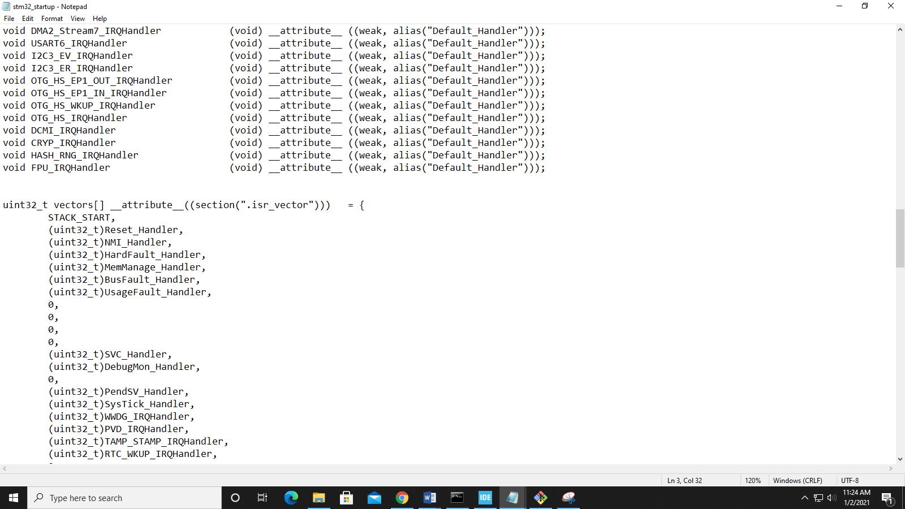

**Activity-4:**

**Makefile:**

